The ChalleNGer PR

**Issue 61**

**August 2021**

**MOUNTAINEER CHALLENGE ACADEMY**

**Class 1-2021**

**Graduate Zackuary Johnson enlisted in the United States Army. He is currently at basic training.**

**Class 2-2020**

**Graduate Ethan Crawford enlisted in the United States Marine Corps and is currently at basic training.**

**Class 1-2021**

Graduate Cameron Calvert is working part time at Dairy Queen.

**Class 2-2020**

Graduate Jenaya McNeil

Is attending Fairmont State University for Criminal Justice

**Class 1-2021**

Graduate Robert Fowlkes

Is working part time at Edgewood Country Club.

**Class 1-2021**

Graduate Kevin Healey is working part time at Bruce Hardware.

**Class 2-2020**

Graduate Kainon Doyle enlisted in the Army National Guard. He is currently at basic training.

**Class 2-2020**

Graduate Alex Shumaker enlisted in the United States Navy. He ships to basic training on September 7, 2021.

**ALL JOB LISTINGS CAN BE FOUND @ www.indeed.com**

**PLACEMENT OPPORTUNITIES**

**WV Regional DMV Offices:**

**1800.642.9066 or 304.558.3900**

Beckley

Charles Town

Clarksburg

Elkins

Flatwoods

Franklin

Huntington

Kanawha City (Charleston)

Lewisburg

Logan

Martinsburg

Moorefield

Morgantown

Moundsville

Parkersburg

Point Pleasant

Princeton

Romney

Spencer

Summersville

Weirton

Welch

Williamson

Winfield

**WV Military**

**Recruitment Offices**

Army National Guard

Contact Sgt. Dustin Durst 304.982.0558

Army

Morgantown 598.0105

Elkins 636.1510

Martinsburg 263.0936

Parkersburg 428.5202

Ripley 372.2224

Point Pleasant 675.3410

Dunbar 744.6491

Fairmont 363.1682

Navy

Morgantown 598.3050

Charleston 746.4641

Parkersburg 420.6014

Bridgeport 842.6045

Air Force

Barboursville 733.1073

Morgantown 599.3087

Bridgeport 842.4285

Charleston 744.0754

Beckley 252.3350

Martinsburg 263.5089

Parkersburg 485.5331

Air Guard

Charleston 341.6125

Martinsburg 616.5386

Marines

Morgantown 599.5547

Martinsburg 267.6733

Parkersburg 422.1521

Nutter Fort 624.6163

Coast Guard

Falling Waters 271.2400

Charleston 347.5106

**Classroom Assistant**

School Days Child Care, LLC

Buckeye, WV 24924

$8.75 - $9.50 an hour - Part-time

**Team Member Winfield Wendy's**

Schmidt Family Restaurant Group

Winfield, WV 25213

$10 - $12 an hour - Full-time, Part-time

**Customer Service Representative**

DIRECTV

Huntington, WV

$15.69 - $17.62 an hour - Full-time

**Picker Packer - Urgent Hire-**

Amazon Workforce Staffing

Inwood, WV 25428

Full-time

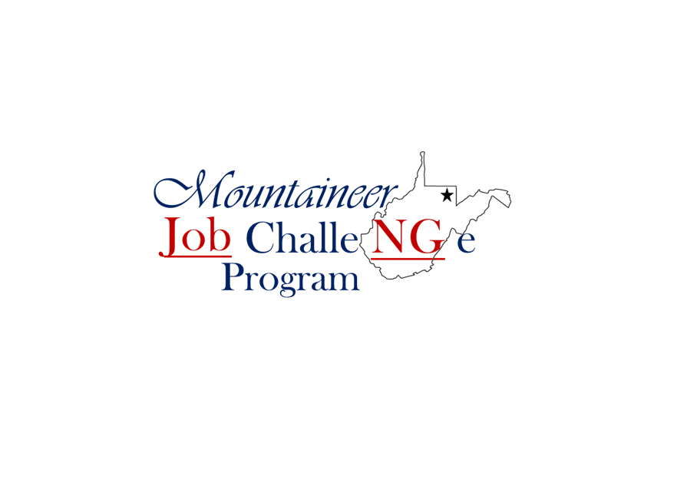

**NOW OFFERING TASC PROGRAM**

**Must have completed at least 2 sections**

**of the TASC exam prior to attending**

**For more information**

**please call**

**304-435-5231**

**Mentors**

**Do forget to send in your reports monthly!**

**Graduates**

**Do not forget to utilize your**

**Virtual Job Shadow accounts**

**For Job searching and resume writing!**

**Customer Service Representative**

Work from Home

TTEC - West Virginia

$11.50 - $16.00 an hour - Full-time