***The ChalleNGer***

**Class 1-21, Issue 4 06/18/21 – 07/08/2021**

4th PROGRESS REPORT AWARD WINNERS

[www.wvchallenge](http://www.wvchallenge).org

*HONOR PLATOON*

**4th Platoon**

|  |  |  |
| --- | --- | --- |
| DIRECTOR’S AWARD |  | **Cadet William Farkas** |
| LEADERSHIP AWARD |  | **Cadet Mason French** |
| PHYSICAL TRAINING AWARD |  | **Cadet Mason French** |

Level One PT

Cadet Eric Clark

Cadet William Farkas

Cadet Mason French

Cadet Camron Fuller

Cadet Tanner Young

Cadet Lawrence Moore

|  |
| --- |
| HIGHEST ACADEMIC POINTS |
| Cadet William Farkas |
|  |

|  |
| --- |
| ***CADET OF THE WEEK*** |
|  |
| Cadet Corey Sparks  Cadet Evan Shifflett |
|  |

|  |  |  |  |
| --- | --- | --- | --- |
| OVERALL | ACADEMIC | PT | CADRE |
| MOST IMPROVED | MOST IMPROVED | MOST IMPROVED | DISTINCTION AWARD |
| **Cadet Elliott Risk** | **Cadet Evan Shifflett** | **Cadet Chandler Randolph** | **Cadet Brooklyn Parker** |

HONOR’S LIST

Cadet Hunter Lane

Cadet Evan Shifflett

Cadet Brooklyn Parker

Cadet Robert Harrah

Cadet Abagail Ross

S2C Award

Cadet Nevaeh Asbury

Cadet Emily Hypes

Cadet Tanner Young

Cadet Audrey Martin

Cadet Samuel Wheeler

|  |
| --- |
| LEADERSHIP APPOINTMENTS |
| Corps Commander: |
| Cadet William Farkas |
| Assistant Corps Commander: |
| Cadet Mason French |
| Platoon Leaders: |
| Cadet Brooklyn Parker |
| Cadet Trevor Conway |
| Cadet Andrew Gosnell |
| Cadet Elliott Risk |
| Cadet Evan Shifflett |
|  |
| Assistant Platoon Leaders: |
| Cadet Samantha Hammons |
| Cadet Abagail Ross |
| Cadet Marekai Daniels |
| Cadet Jordan Delgado |
| Cadet Lawrence Moore |
| Cadet Corey Sparks |

|  |  |  |  |
| --- | --- | --- | --- |
| INSTRUCTORS LIST | | | |
|  |  | | |
| Cadet Jade Swartzel  Cadet Lawrence Moore  Cadet Jonathan Luffman  Cadet William Farkas  Cadet Nevaeh Asbury  Cadet Mason Seward  Cadet Emily Hypes  Cadet Hunter Lane  Cadet Austin Conley  Cadet Gideon Hoylman  Cadet Gage Pomp | |  |  |
|  |  |
|  |  |
|  |  |
|  |  |

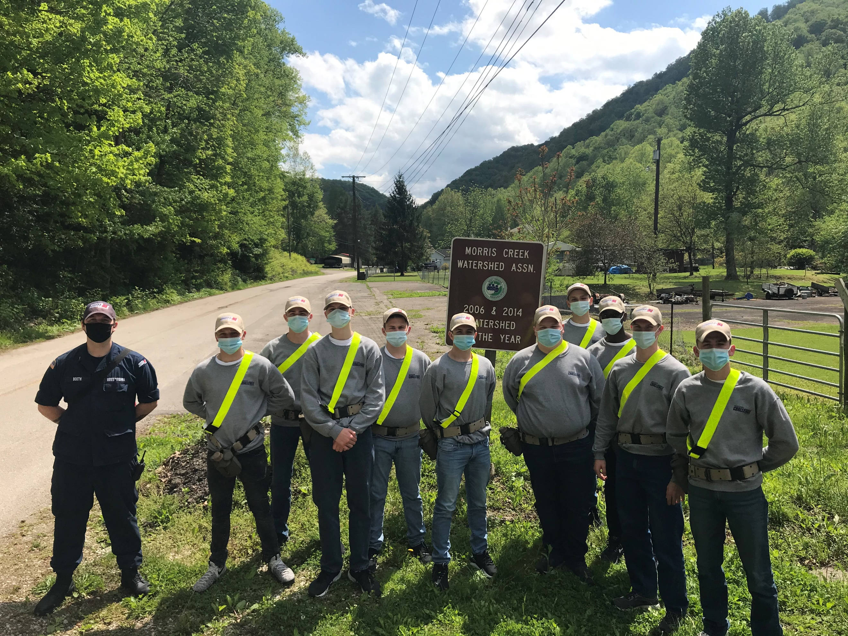

**What’s new?**

During progress reporting period 4, Cadets went on summer break to celebrate the July 4th holiday with loved ones. We welcomed Cadets back to MCA on July 9th.

Cadets were able to participate in a job fair hosted at MCA. Representatives from branches of the military, EMS, police departments, and colleges and more were here to speak to Cadets about their post residential options.

**Service to Community (S2C)**

During weeks 3-19 of the Residential Phase, the Cadets receive instruction centered around the 8 Core Components. One of these Core Components is Service to Community. Cadets develop an understanding of the benefits to be gained through volunteerism in community service projects and agencies. In addition to performing regular area beautification of the campus grounds, Cadets have participated with the Morris Creek Water Shed to replace community basketball hoops, pave walking paths, and trash clean up. Cadets have also had the opportunity to leave their mark on the town by helping with a building mural.

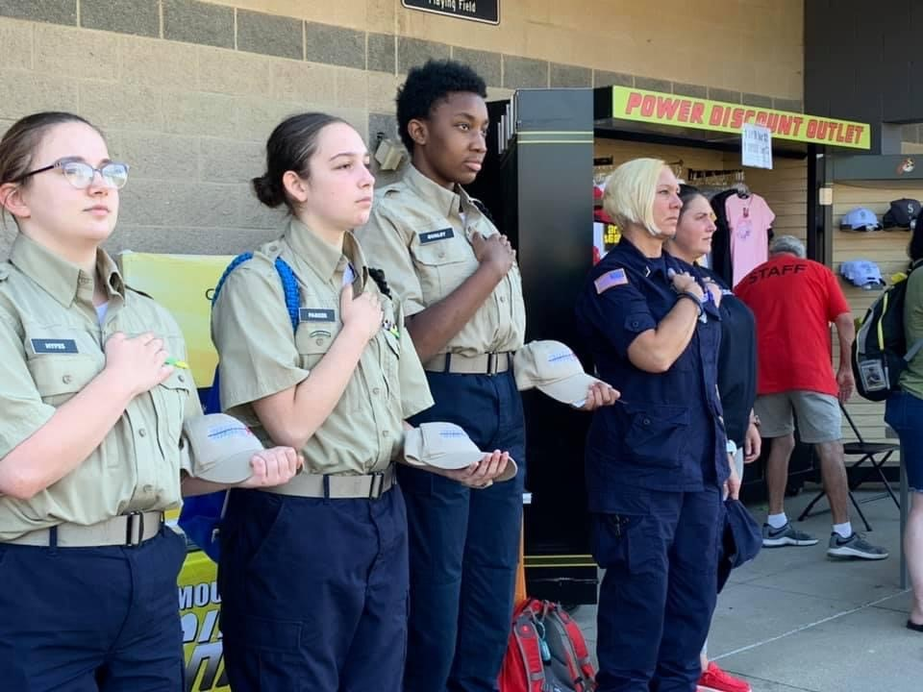

|  |
| --- |
| *Important Information* |
| Optional Purchase Available  Class Ring!    Please contact Balfour for information at 304 599-0621. |
| Graduation  Graduation is coming up quickly! Please watch the Mountaineer Challenge Academy South Facebook page for information coming soon! |

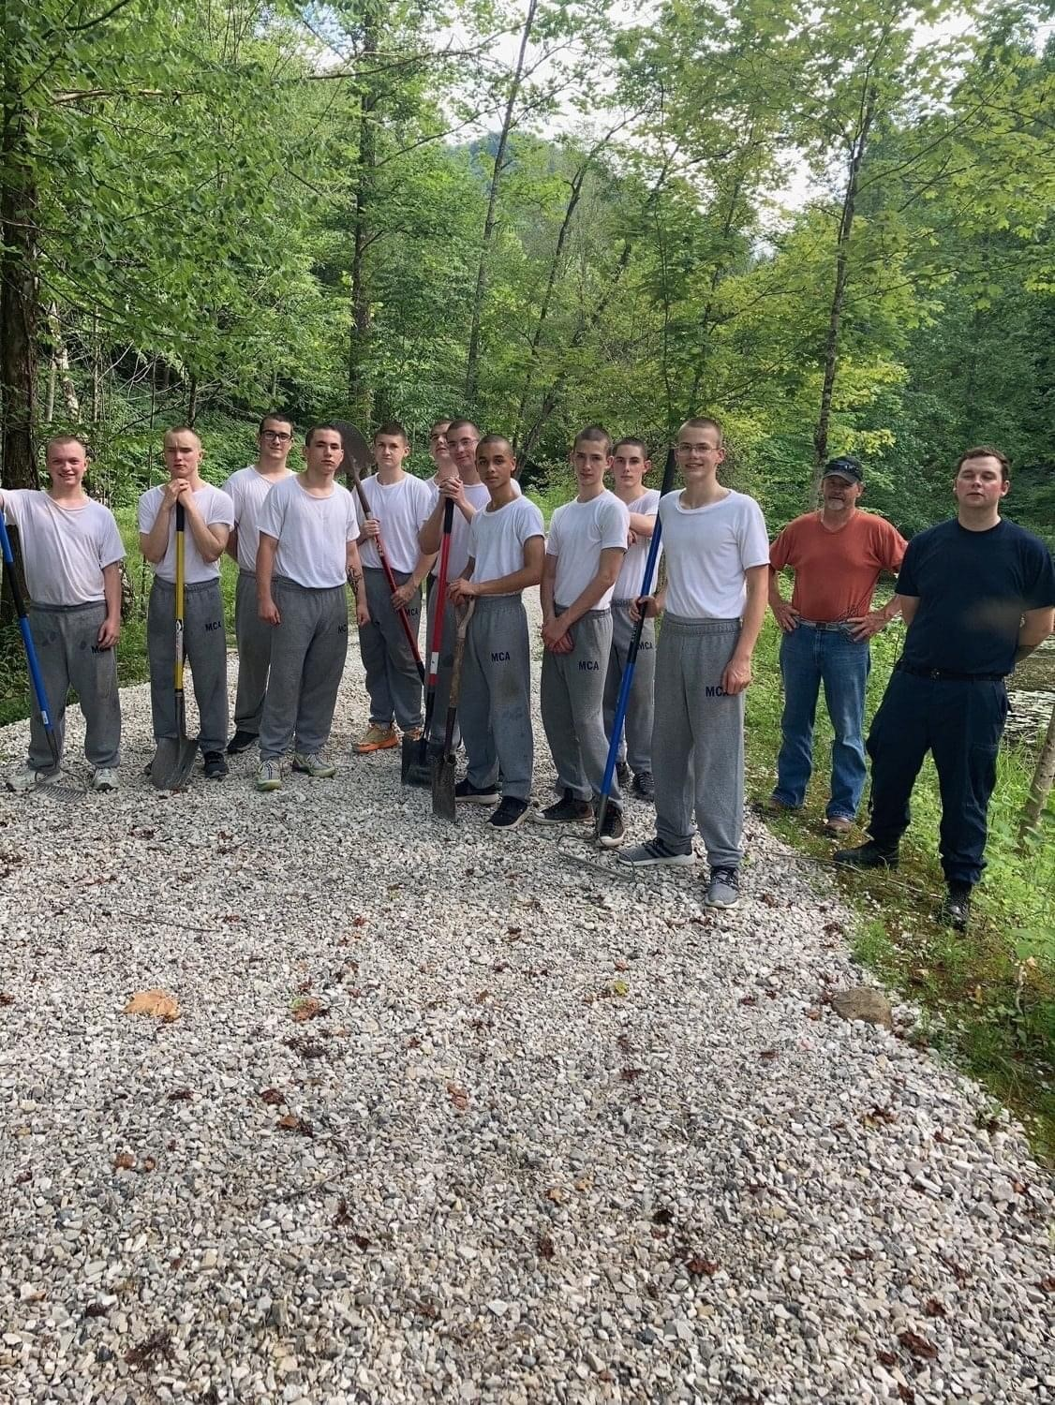 

## What does an MCA Class Ring look like?

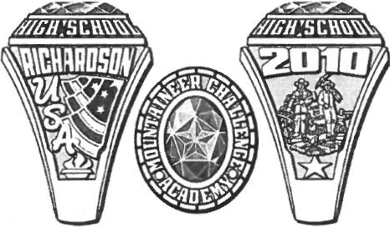

**This design was selected by the first graduating class.**

|  |
| --- |
| *SCHEDULE OF EVENTS* |
| |  |  | | --- | --- | |  |  | | **07/29** | **5th Grading Period Ends** | | **7/19** | **ASVAB retest** | | **7/20** | **TASC Writing test** | | **8/3-8/6** | **TASC Readiness test** | | **8/5** | **5th PR Awards** | |  |  | |  |  | |  |  | |  |  | |

|  |
| --- |
| TRUSTWORTHINESS RIBBON |
|  |
| **All Cadets who completed the fourth progress report received the Trustworthiness Ribbon. The blue ribbon represents the need to be honest, be reliable and do what you say you will do. Have the courage to do the right thing and always live by your “Honor Code.” Be someone who others can trust.** |