***The ChalleNGer***

**Class 1-21, Issue 3 05/28/21-06/17/21**

3nd PROGRESS REPORT AWARD WINNERS

[www.wvchallenge](http://www.wvchallenge).org

|  |
| --- |
| ***CADET OF THE WEEK*** |
|  |
| Cadet Ralph Culp  Cadet Brooklyn Parker  Cadet Elijah Combs |
| **LEVEL ONE PT**  Cadet Mason French  Cadet Camron Fuller  Cadet Lawrence Moore  Cadet Samuel Wheeler  Cadet Xian Murray  Cadet William Farkas |

*HONOR PLATOON*

*5TH Platoon*

*ONOR PLATOON*

*1st Platoon*

|  |  |  |
| --- | --- | --- |
| DIRECTOR’S AWARD |  | **Cadet William Farkas** |
| LEADERSHIP AWARD |  | **Cadet Mason French** |
| PHYSICAL TRAINING AWARD |  | **Cadet William Farkas** |

|  |  |  |  |
| --- | --- | --- | --- |
| OVERALL | ACADEMIC | PT | CADRE |
| MOST IMPROVED | MOST IMPROVED | MOST IMPROVED | DISTINCTION AWARD |
| **Cadet Samuel Wheeler** | **Cadet Abagail Ross** | **Cadet Lawrence Moore** | **Cadet Andrew Gosnell** |

HIGHEST ACADEMIC POINTS

Cadet William Farkas

S2C AWARD

Cadet Jade Swartzel Cadet Bella Seese

Cadet Robert Harrah Cadet Nathan Kennedy

Cadet Colton Bunner Cadet Marekai Daniels

Cadet William Farkas Cadet Brooklyn Parker

HONOR’S LIST

Cadet Nevaeh Asbury

Cadet Elliott Risk

Cadet William Farkas

Cadet Bella Seese

Cadet Austin Watson

|  |
| --- |
| 3-D AWARD |
|  |
| Cadet Marekai Daniels  Cadet Tyler Benedum  Cadet Colton Bunner  Cadet Jordan Delgado  Cadet Isaiah Keeney  Cadet Jimmy Allen  Cadet Andrew Hamilton  Cadet Brennen Beard  Cadet Ralph Culp  Cadet Eric Clark  Cadet Donovan Clark  Cadet Austin Conley  Cadet Andrew Gosnell  Cadet Brooklyn Parker |

|  |
| --- |
| INSTRUCTOR’S LIST |
| Cadet Jimmy Allen  Cadet Brennen Beard  Cadet Colton Bunner  Cadet Elijah Combs  Cadet Trevor Conway  Cadet Jordan Delgado  Cadet Cadet Camron Fuller  Cadet Logan Hill  Cadet Kayle Gurley  Cadet Nathan Kennedy  Cadet Audrey Martin  Cadet Landon Moore  Cadet Nevaeh Asbury  Cadet Tyler Benedum  Cadet Donovan Clark  Cadet November Cornell  Cadet Marekai Daniels  Cadet Christopher Dotson  Cadet Andrew Hamilton  Cadet Emily Hypes  Cadet Isaiah Keeney  Cadet Walker Light  Cadet Lawrence Moore  Cadet Xian Murray  Cadet Landry Pickens  Cadet Gage Repine  Cadet Abagail Ross  Cadet Destiny Ross  Cadet Christopher Salmon  Cadet Mason Seward |

|  |
| --- |
| LEADERSHIP APPOINTMENTS |
| *Corps Commander:* |
| Cadet William Farkas |
| *Assistant Corps Commander:* |
| Cadet Mason French |
| *Platoon Leaders:* |
| Cadet Brooklyn Parker |
| Cadet Xian Murray |
| Cadet Andrew Gosnell |
| Cadet Lawrence Moore |
| Cadet Christopher Salmon |
|  |
| *Assistant Platoon Leaders:* |
| Cadet Samantha Hammons |
| Cadet Marekai Daniels |
| Cadet Camron Fuller |
| Cadet Elliott Risk |
| Cadet Robert Harrah |
|  |

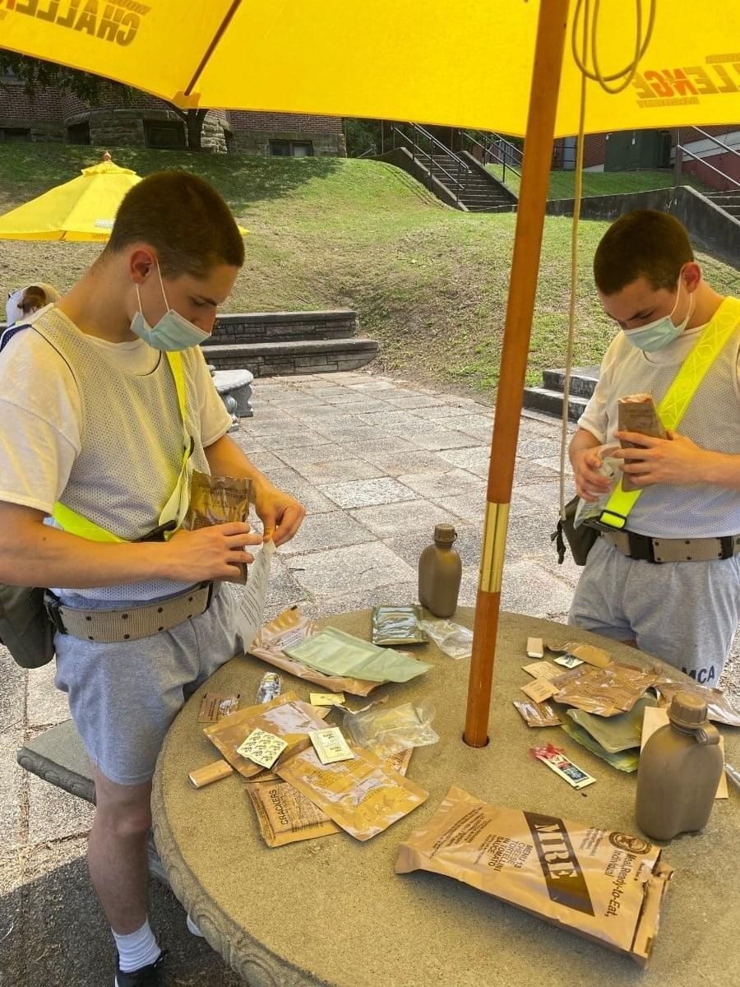

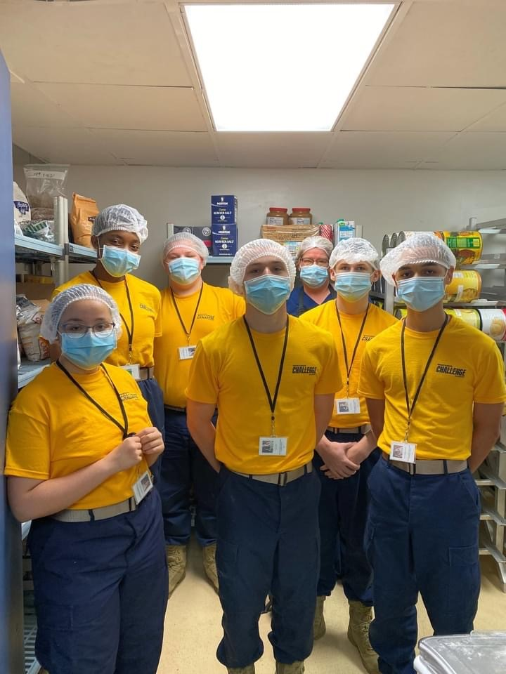

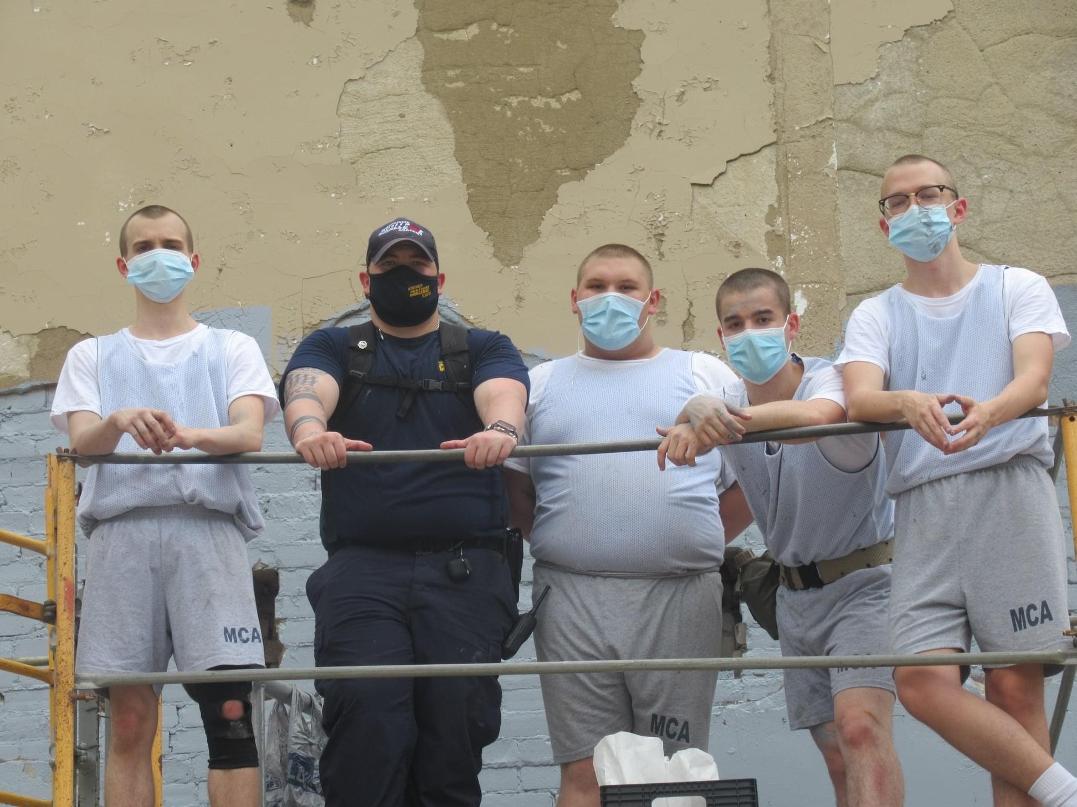

Above left…Cadets received community service

hours by helping to paint a mural on one of the buildings in Montgomery. Above middle…Members of the Serv Safe Club had the opportunity to help in the DFAC to work on their culinary skills. Above right…Cadets in Military prep were able to try MRE’s. Middle left…Some cadets from our Challenge Team took part in the WV National Guard Flag Day celebration and competed the six mile Ruck March. Lower left…Cadets traded in their merits for delicious banana splits made by our DFAC staff. Lower right…Platoon 1 got in some marching practice.

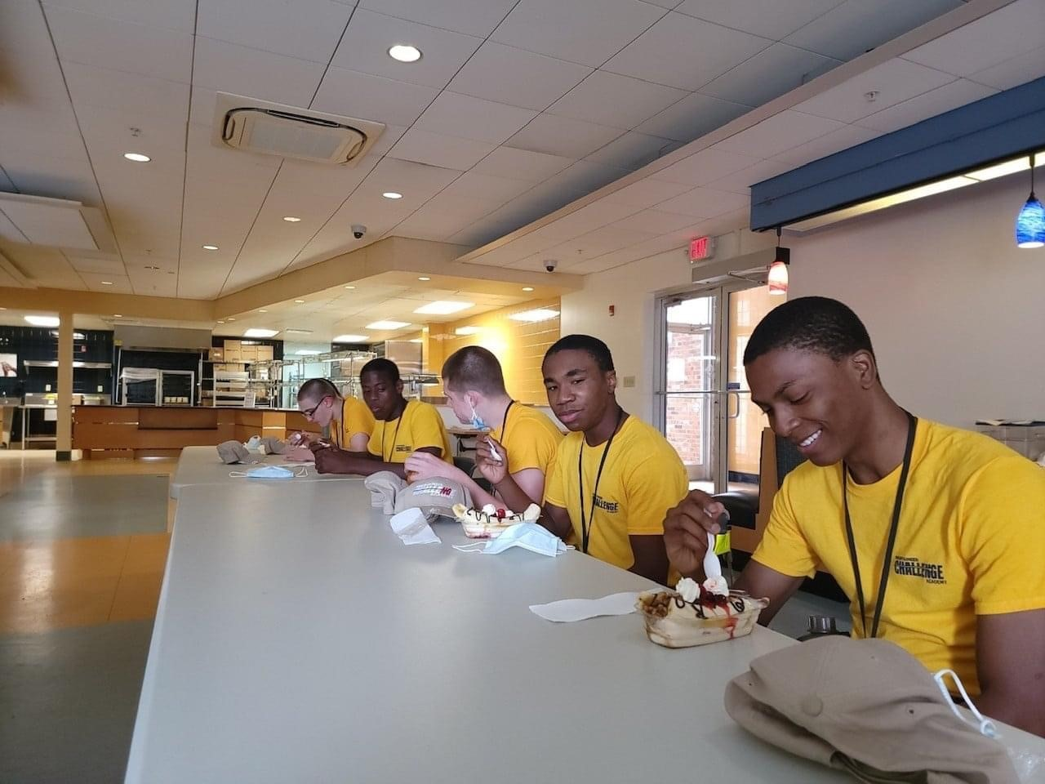

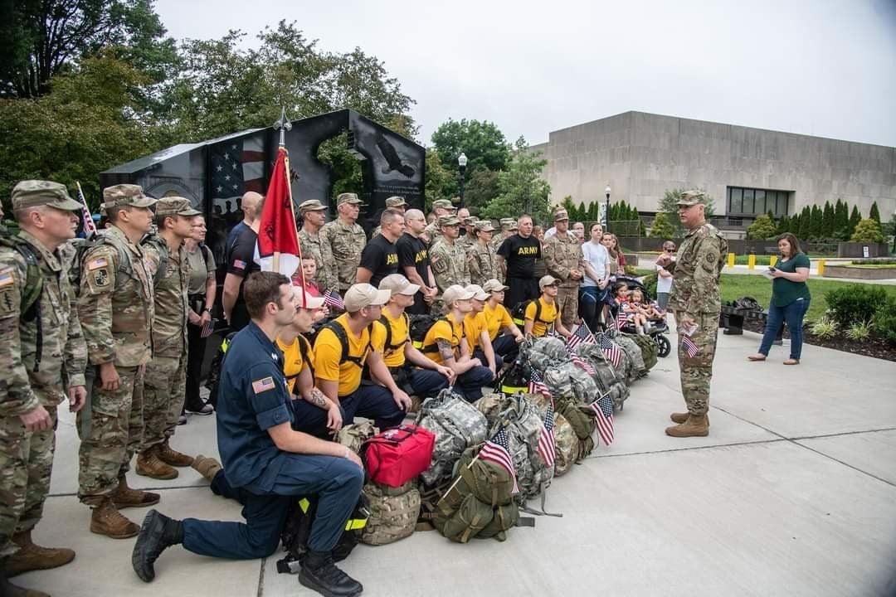

**Fairness Ribbon**

All Cadets who completed the third progress reporting period received the orange Fairness Streamer! The fairness streamer means you play by the rules, be open-minded, do not take advantage of others and do not blame others. Treat people fairly, do what is right and not what your friends do. Be a leader and not a follower!

Do you know a teen who could benefit from the mca?

Tell them or their family member to call

1-800-529-7700

Schedule of Events!

July 1 PR4 Grades are due

July 2 Leave starts

July 9 Leave ends

July 15 PR4 Awards

**\*\*If you haven’t already turned in a baby picture, please bring it when you drop your cadet off from leave on July 9th! \*\***