***The ChalleNGer***

**Class 1-21, Issue 2 05/07/21-05/27/21**

2nd PROGRESS REPORT AWARD WINNERS

[www.wvchallenge](http://www.wvchallenge).org

|  |
| --- |
| ***CADET OF THE WEEK*** |
|  |
| Cadet Andrew Gosnell |
| Cadet William Farkas |
| Cadet Brooklyn Parker |
|  |

*HONOR PLATOON*

*3rd Platoon*

|  |  |  |
| --- | --- | --- |
| DIRECTOR’S AWARD |  | **Cadet William Farkas** |
| LEADERSHIP AWARD |  | **Cadet Mason French** |
| PHYSICAL TRAINING AWARD |  | **Cadet William Farkas** |

**Mentorship**

Cadet Jimmy Allen

Cadet Ny’Anza Bragg

Cadet Evan Shifflett

Cadet Christopher Salmon

Cadet Jordan Delgado

Cadet Hunter Lane

Cadet Johnathan Luffman

Cadet Isaiah Keeney

|  |  |  |  |
| --- | --- | --- | --- |
| OVERALL | ACADEMIC | PT | CADRE |
| MOST IMPROVED | MOST IMPROVED | MOST IMPROVED | DISTINCTION AWARD |
| **Cadet Camron Fuller** | **Cadet Mason Seward** | **Cadet Christopher Dotson** | **Cadet William Farkas** |

HIGHEST ACADEMIC POINTS

Cadet Destiny Ross

Cadet Andrew Gosnell

Cadet William Farkas

S2C AWARD

Cadet Landon Moore

HONOR’S LIST

Cadet Christopher Salmon

Cadet Corey Sparks

Cadet Mason French

|  |
| --- |
| RESPONSIBILITY RIBBON |
|  |
| **All Cadets who completed the second progress reporting period received the Responsibility Ribbon. The green ribbon represents the need to do what you are supposed to do and be where you are supposed to be. Plan ahead, persevere and keep on trying! Always do your best. Use self-control, be self-disciplined, think before you act and consider the consequences. Be accountable for your words, actions, and attitudes. Set a good example for others. The Golden Rule illustrates the pillar of respect, “Do unto others as you would have them do unto you.”** |

|  |
| --- |
| LEADERSHIP APPOINTMENTS |
| *Corps Commander:* |
| Cadet William Farkas |
| *Assistant Corps Commander:* |
| Cadet Mason French |
| *Platoon Leaders:* |
| Cadet Samantha Hammons |
| Cadet Xian Murray |
| Cadet Andrew Gosnell |
| Cadet Elijah Combs |
| Cadet Christopher Salmon |
|  |
| *Assistant Platoon Leaders:* |
| Cadet Israel Perrine |
| Cadet Trevor Conway |
| Cadet Camron Fuller |
| Cadet Lawrence Moore |
| Cadet Samuel Wheeler |
|  |

|  |  |  |
| --- | --- | --- |
| INSTRUCTOR’S LIST | |  |
| Cadet Eric Clark | Cadet Ralph Culp |  |
| Cadet Tanner Estep | Cadet William Farkas |  |
| Cadet Mason French | Cadet Andrew Gosnell |  |
| Cadet Robert Harrah | Cadet Austin Hartley |  |
| Cadet Brooklyn Parker | Cadet Israel Perrine |  |
| Cadet Chandler Randolph | Cadet Elliott Risk |  |
| Cadet Shaun Schell | Cadet Bella Seese |  |
| Cadet Evan Shifflett | Cadet Isaiah Simmons |  |
| Cadet Corey Sparks | Cadet Nathan Trail |  |
| Cadet Austin Watson | Cadet Samuel Wheeler |  |
| Cadet Tanner Young |  |  |
|  |  |  |



Cadets were placed in real life scenarios that forced them to improvise life saving measures.

The ChalleNGe Team is comprised of Cadets that have excelled in physical fitness, conduct, and mental agility. Selected by the Commandant of Cadets, the ChalleNGe Team will represent MCA South in competitions within the region.

Cadets getting more S2C hours with community clean up.

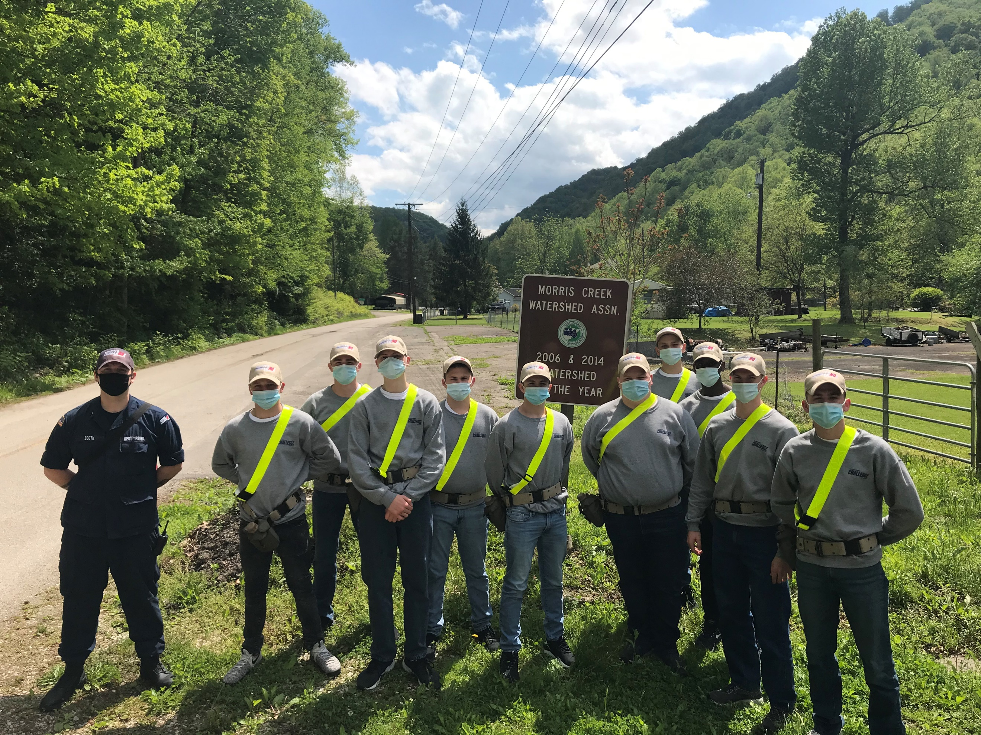

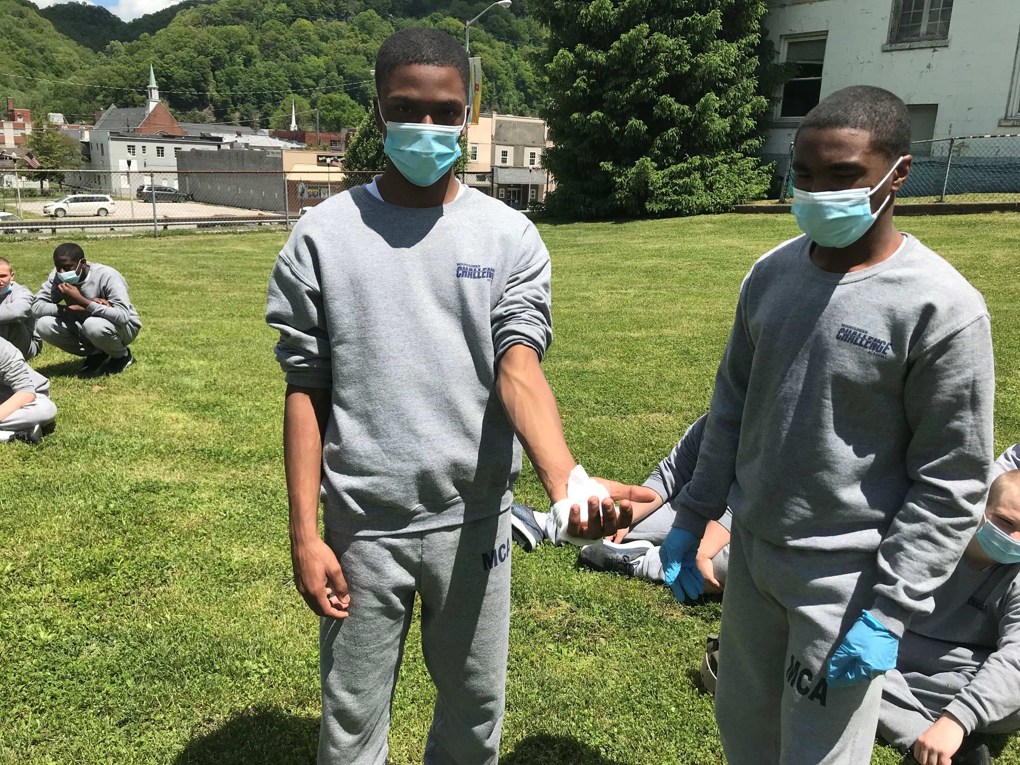



Cadets honored our fallen Military Service Members on Memorial Day with a Flag raising ceremony, wreath laying ceremony, and a moment of silence. The event was complete with a statement read by Mr. Perdue. If you missed the service, you can still watch on our Facebook page at

Mountaineer ChalleNGe Academy South.

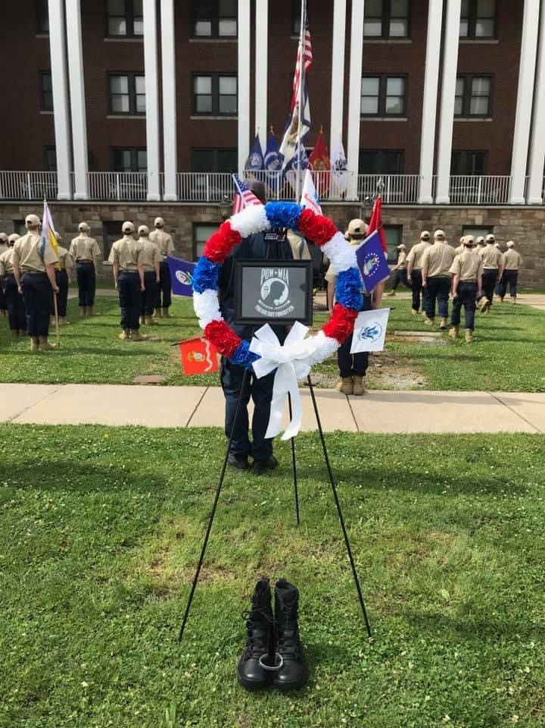



|  |
| --- |
| *SCHEDULE OF EVENTS* |
| |  |  | | --- | --- | | **06/17** | **3rd Grading period ends** | | **07/02** | **Leave begins** | | **07/09** | **Leave ends** | | **06/24** | **3rd Grading period awards** | |

Cadets have gotten some S2C hours working with the Morris Creek Watershed.

5th Platoon took part in decorating the graves of Veterans at the Donel C. Kinnard Memorial State Veterans Cemetery.



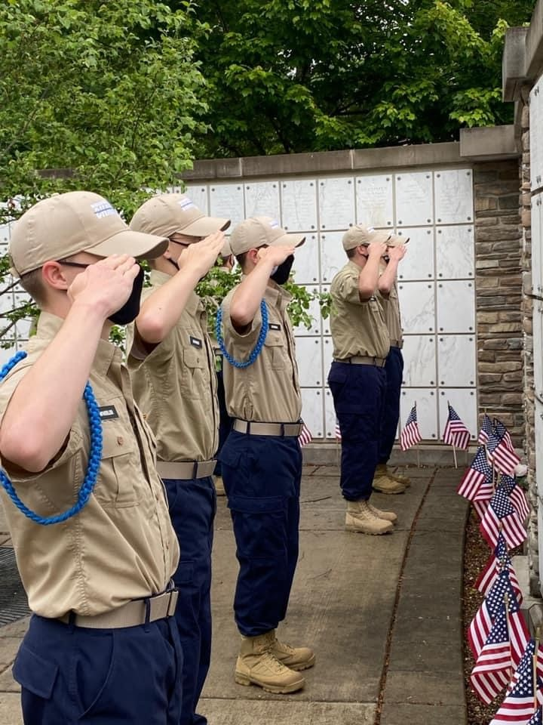

Do you know a teen who could benefit from the mca?

Classes are now forming!

Tell them or their family member to call

1-800-529-7700