The ChalleNGer

CADET OF THE WEEK
Individuals chosen as Cadet of the Week are selected from the Platoon of which they are a member. The Squad Leaders will inspect the Platoon. Platoon winners compete for the title of “Cadet of the Week” by answering questions related to MCA, State of WV, or TASC topics.

04/28 | Hunter Lane
5/04 | Mason French
Class 1-21, Issue 1 04/11/2021 – 05/06/2021
1st PROGRESS REPORT AWARD WINNERS
Being Unique Is What This Class Is All About

As the COVID-19 pandemic continues throughout the United States, the Mountaineer ChalleNGe Academy continues to move forward with the start of Class 1-21 on April 11, 2021. With this being said, we had a great opening day.

- Opening Day itself was conducted at the David S. Alumni House in Montgomery. Here, we had an outside processing center with mobile COVID testing conducted on each candidate. From there, they were welcomed into their new home away from home on the old campus of WVUIT here in Montgomery.
- Because of Covid restrictions, the number of Candidates invited was limited.
- The faces of the Candidates were all filled with anticipation and excitement as they started this new endeavor in their lives!
- Halfway through their acclimation period, they received the traditional bag of chips and sprite on Sunday, April 18th.
- The Platoon Olympics took place on April 23^{rd.}
- Cadets took their pre-Tabe testing on Friday, April 17th.
- Classroom teaching began on Monday, April 26th with a variety of hands-on learning activities to keep the Cadets engaged and learning.
- MCA is running as a closed campus, but letters to our cadets are always welcome!

Thank you, MCA South Class 2, for stepping up and committing to completing the ChalleNGe!
www.wvchallenge.org
LEADERSHIP APPOINTMENTS
Corps Commander
William Farkas
Assistant Corps Commander
Mason French
Platoon Leaders:
Samantha Hammons
Xian Murray
Camron Fuller
Elijah Combs
Robert Harrah
Assistant Platoon Leaders:
Israel Perrine
Trevor Conway
Tanner Young
Walker Light
Samuel Wheeler

HONOR PLATOON
2nd Platoon

HIGHEST ACADEMIC POINTS
Samantha Hammons
Colton Bunner
Mason French
Robert Harrah
Elijah Combs
Hunter Lane
Landon Moore
Elliott Risk

CADRE DISTINCTION AWARD
Xian Murray

LEVEL ONE PT
Xian Murray
William Farkas

DIRECTOR’S AWARD |  | William Farkas of Preston County
LEADERSHIP AWARD |  | Mason French of Lincoln County
PHYSICAL TRAINING AWARD |  | Xian Murray of Kanawha County

S2C AWARD
Samantha Hammons
Tanner Young

Guidon Presentation
Successful completion of the Acclimation phase was celebrated with the presentation of the MCA colors to the class of 1-21. The Company Guidon is the cornerstone on which to build team performances and individual achievements. The Company Guidon is designated by the Class Streamer with the class number and the phase streamers that signify class progress during the program. All Platoons received their individual Guidons, which identify the Platoon number and mascot. Award Streamers are presented every three weeks to recognize their accomplishments in education, PT, Service to Community and conduct.
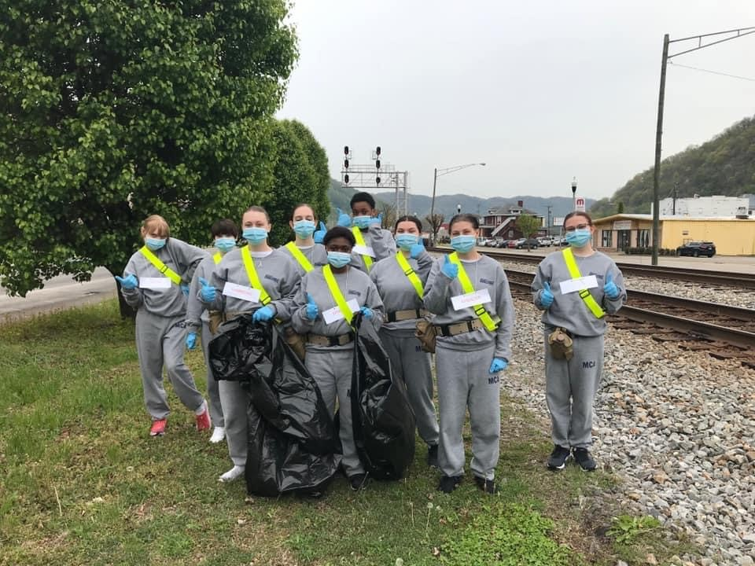
Cadets Enjoy Platoon Olympics
On Friday, April 23rd, the Cadets participated in MCA Platoon Olympics. In order to maintain social distancing, Platoon Olympics took place outdoors on the football field. The Cadets and staff all loved being a part of such a great day. Each of the 5 Platoons competed in the following events: Formation, memorization table, football throw, hula hoop race, knowledge relay, tug o’ war, and the knock out drill. Platoon 5 was the first-place winner and was honored by getting to be the first in the Chow Line.

RESPECT RIBBON
All Cadets who completed the First Progress Report received the Respect Ribbon. Treat others the way you want to be treated. Respect the dignity, privacy, and freedom of all individuals. Value and honor all people, no matter what they can do for you or to you. Respect others, the Academy, yourself and follow the ‘Golden Rule.’ Self-respect leads to self-discipline. Self-Discipline is the art of resisting the temptations of life.

Did You Know?
- Mountaineer ChalleNGe Academy offers a salad with every lunch and dinner. Vegetables are an important source of fiber. Fiber helps keep blood sugar stable throughout the day, preventing the peaks and crashes that have us craving sweets.
- Cadets carry canteens and are encouraged to drink eight 8 ounce glasses of water a day. Staying hydrated improves all bodily functions at the cellular level and helps your heart and kidneys work more efficiently. Water carries nutrients and antioxidants to our tissue, resulting in an energy boost.
- Cadets are offered unsweetened ice tea with meals. Unsweetened tea is a zero calorie beverage that may promote heart health by improving blood vessel function.
- Daily physical training helps Cadets stay fit and happy. Because of the calming effect of exercise, active people are less depressed and depressed people often feel better after they start exercising.
- Cadets eat more whole grain products than white, like brown rice and wheat bread. Higher in protein and fiber, whole grain foods keep your blood sugar in check and keep you feeling full longer. Whole grains are versatile, inexpensive and surprisingly easy to prepare.
Source: The Biggest Loser Simple Swaps 100 Easy Changes to Start Living a Healthier Lifestyle

IMPORTANT INFORMATION
If you have questions or concerns regarding your child’s medical care or medications – please call the MCA Medical Office at 304-981-0031. You may leave a message at any time.

Cadets may NOT receive packages in the mail. Nothing bigger than a greeting card sized envelope or a #10 business envelope is allowed. Stamps are allowed to be included in these mailings.

When writing to Cadets, please make sure your complete name and return address is included on the front of the envelope. Please pass this on to all family and friends!

SCHEDULE OF EVENTS
05/27 | 2nd Grading Period Ends
06/03 | PR 2 Awards Ceremony
06/17 | 3rd Grading Period Ends
06/24 | PR 3 Awards Ceremony

Do you know a teen who could benefit from the mca?

Tell them or their family member to call
1-800-529-7700

