The ChalleNGer PR

**Issue 59**

**May 2021**

**MOUNTAINEER CHALLENGE ACADEMY**

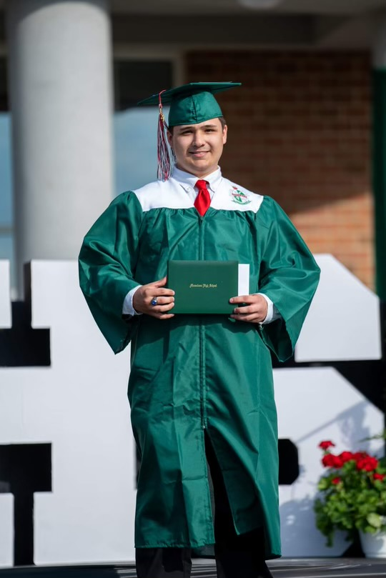

**Class 1-2020**

**Graduate Caleb Easterling graduated from Musselman High School on May 27, 2021.**

**Class 2-2020**

**Graduate Brialyn Strahin completed the Welding program at Mountaineer Job ChalleNGe Program on**

**May 5, 2021.**

**Class 1-2020**

Graduate Seth Mowery is working full time for Inwood Truck and Trailer Repair.

**Class 2-2020**

Graduate Alexzander Sweeney enlisted in the United States Army and is currently at basic training.

**Class 2-2020**

Graduate Jenaya McNeil received her high school diploma and applied to college.

**Class 2-2020**

Graduate Hunter Saunders is working full time at FOP Restaurant.

**Class 2-2020**

Graduate Hanna Starcher is working full time at Swan Bay Resort.

**Attention Cadets**

**If you would like to be featured on our monthly newsletter, please have someone take a picture of you in uniform and/or at work and send to your RPM Assistant.**

**RPM Assistant’s**

**Contact Information**

**Mrs. Carpenter**

304.791.7387 or 304.276.9857

[**brittany.d.carpenter@wv.gov**](mailto:brittany.d.carpenter@wv.gov)

**Mrs. Lowdermilk**

**304.791.7386 or 304.282.4313**

[**michelle.b.lowdermilk@wv.gov**](mailto:michelle.b.lowdermilk@wv.gov)

**Mrs. Manier**

304.791.7385 or 304.435.5419

[**stephanie.g.manier@wv.gov**](mailto:stephanie.g.manier@wv.gov)

**Mrs. McCrobie**

**304.791.7384 or 304.435.5298**

[**hannah.r.mccrobie@wv.gov**](mailto:hannah.r.mccrobie@wv.gov)

**Ms. Thomas**

304.791.7388 or 304.376.6376

[**makena.g.thomas@wv.gov**](mailto:makena.g.thomas@wv.gov)

**Class 2-2019**

**Digital yearbooks will be mailed out as soon as possible**



PLACEMENT OPPORTUNITIES

**Holiday Inn Express**

All positions open

$9.00 to $10.50 an hour

Full and Part Time

Charleston, WV

**WV Regional DMV Offices:**

**1800.642.9066 or 304.558.3900**

Beckley

Charles Town

Clarksburg

Elkins

Flatwoods

Franklin

Huntington

Kanawha City (Charleston)

Lewisburg

Logan

Martinsburg

Moorefield

Morgantown

Moundsville

Parkersburg

Point Pleasant

Princeton

Romney

Spencer

Summersville

Weirton

Welch

Williamson

Winfield

**Sonic**

Crew Member

Full and Part Time

Day and Night Shift

Multiple Locations



**Sweet Frog**

Martinsburg, WV

Part Time





**KFC**

Crew Member

Elkview, WV

Full Time

**Graduates**

**Do not forget to utilize your Virtual Job Shadow accounts for**

**Job searching and resume writing!**

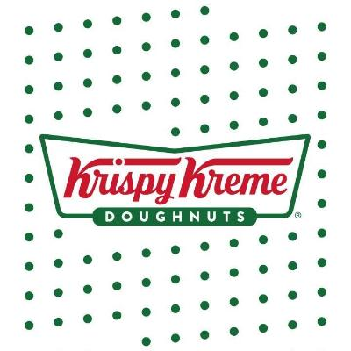****





**Wendy’s**

Team Member

Part Time

$10-$12 per/hour

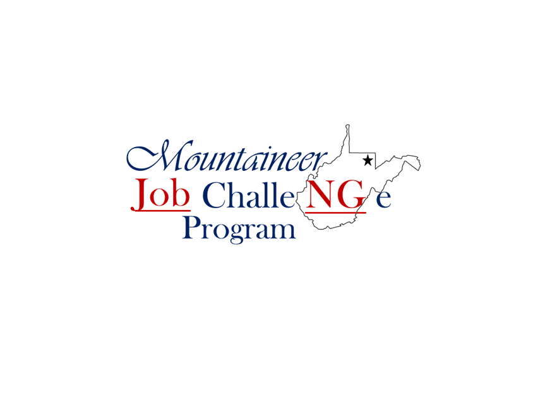

**NOW OFFERING TASC PROGRAM**

**Must have completed at least 2 sections**

**of the TASC exam prior to attending**

**For more information**

**please call**

**304-435-5231**

**Buffalo Wild Wings**

Cashier

Parkersburg, WV

<https://careers.buffalowildwings.com/us/en/job>