The ChalleNGer PR

**Issue 56**

**January 2021**

**MOUNTAINEER CHALLENGE ACADEMY**

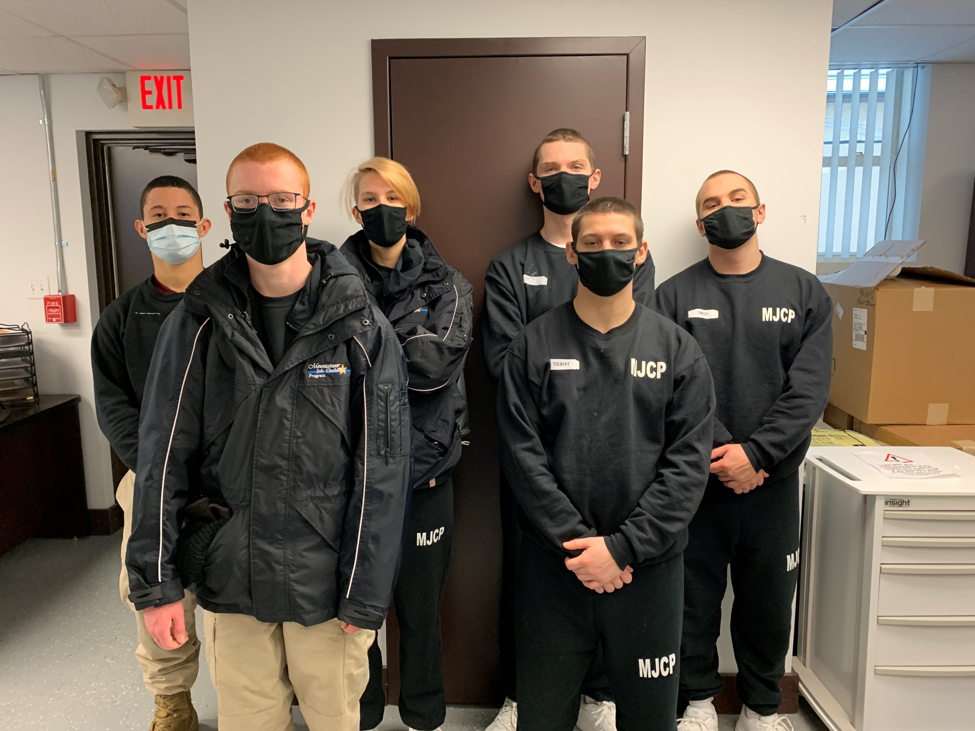

**Class 1-2020**

Graduate Dakota Pauley is working Part time at Walmart.

**Congratulations to the following cadets who are currently attending Mountaineer Jobs ChalleNGe program:**

**Pictured from front to back: Kainon Doyle, Jackie Tolbert, Matthew Fernandes, Brialyn Strahin, Blake Bailey, and Evan Turley**

**Class 2-2020**

Graduate Damian Vankirk is working full time at Pratt and Whitney Aerospace Company in Bridgeport, WV

**Class 2-2020**

Graduate Alexis Robinson is working part time at Chipotle.

**Class 1-2020**

Graduate Aiden Billmyer is working part time at Sheetz.

**Class 2-2020**

Graduate Caroline Fazzolari left for Army basic training on January 18, 2021.

**RPM Assistant’s**

**Contact Information**

**Mrs. Carpenter**

304.791.7387 or 304.276.9857

[**brittany.d.carpenter@wv.gov**](mailto:brittany.d.carpenter@wv.gov)

**Mrs. Lowdermilk**

**304.791.7386 or 304.282.4313**

[**michelle.b.lowdermilk@wv.gov**](mailto:michelle.b.lowdermilk@wv.gov)

**Mrs. Manier**

304.791.7385 or 304.435.5419

[**stephanie.g.manier@wv.gov**](mailto:stephanie.g.manier@wv.gov)

**Mrs. McCrobie**

**304.791.7384 or 304.435.5298**

[**hannah.r.mccrobie@wv.gov**](mailto:hannah.r.mccrobie@wv.gov)

**Mrs. Sypolt**

**304.791.7383 or 304.282.4360**

[**brandy.n.sypolt@wv.gov**](mailto:brandy.n.sypolt@wv.gov)

**Ms. Thomas**

304.791.7388 or 304.376.6376

[**makena.g.thomas@wv.gov**](mailto:makena.g.thomas@wv.gov)

**Class 1-2020**

Graduate Nikita Vaughan enlisted in the United States Air Force. She leaves for basic training in March 2021. She is also employed at Dunkin Donuts as a Shift Manager.

**Attention Cadets**

**If you would like to be featured on our monthly newsletter, please have someone take a picture of you in uniform and/or at work and send to your RPM Assistant.**

**Class 2-2019**

**Digital yearbooks will be mailed out as soon as possible**

PLACEMENT OPPORTUNITIES

# **Guest Service Full Time & Part Time Salary starting at $12.50/hr**

**Many Locations!** [**www.indeed.com**](http://www.indeed.com)

# company logo image

**WV Military**

**Recruitment Offices**

Army National Guard

Contact Sgt. Dustin Durst 304.982.0558

Army

Morgantown 598.0105

Elkins 636.1510

Martinsburg 263.0936

Parkersburg 428.5202

Ripley 372.2224

Point Pleasant 675.3410

Dunbar 744.6491

Fairmont 363.1682

Navy

Morgantown 598.3050

Charleston 746.4641

Parkersburg 420.6014

Bridgeport 842.6045

Air Force

Barboursville 733.1073

Morgantown 599.3087

Bridgeport 842.4285

Charleston 744.0754

Beckley 252.3350

Martinsburg 263.5089

Parkersburg 485.5331

Air Guard

Charleston 341.6125

Martinsburg 616.5386

Marines

Morgantown 599.5547

Martinsburg 267.6733

Parkersburg 422.1521

Nutter Fort 624.6163

Coast Guard

Falling Waters 271.2400

Charleston 347.5106

# **Baristas – Full Time & Part Time Various locations!**

# **https://starbucks.taleo.net/careersection**

# company logo image

# company logo image

# **Guest Service Representative/Housekeeping**

**Surestay Plus by Best Western Keyser, WV**

**Salary $9 - $15 an hour Full-time /Part-time**

[**www.indeed.com**](http://www.indeed.com)

**Retail Garden Center Merchandiser**

**Urgently hiring!**

Salary $10 - $12 an hour

Part Time

<https://www.paycomonline.net>

# Bell Nursery logo



**GRADUATES!**

**Do not forget about your Virtual Job Shadow Account!**

**There is a job search and resume writing tool included!**

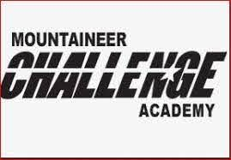

**Mountaineer ChalleNGe Academy South is HIRING!!**

**Located in Montgomery, WV**

**For more information,**

**visit** [**www.wvchallenge.org**](http://www.wvchallenge.org)



**Mountaineer Job ChalleNGe**

**Program**

**Must be 17 ½ - 20 years of age**

**High School Diploma required**

**Training Tracks:**

**Manufacturing Technology**

**Medical Technology**

**Pre- Apprenticeship**

**Commercial Driver License**

**Welding**

**Energy Sector**

**Aviation Structures Tech Training**

**All training tracks are subject to change without notice**

**For more information**

**please call 304-435-5231**