The ChalleNGer

Class 2-20 Issue 6 10/16/2020 – 11/05/2020
www.wvchallenge.org
6th PROGRESS REPORT AWARD WINNERS
HONOR PLATOON
4th Platoon

DIRECTOR’S AWARD |  | Hannah Atkins of Kanawha County
LEADERSHIP AWARD |  | Evan Turley of Wood County
PHYSICAL TRAINING AWARD |  | Alexis Robinson of Kanawha County
OVERALL | ACADEMIC | PT | CADRE
MOST IMPROVED | MOST IMPROVED | MOST IMPROVED | DISTINCTION AWARD
Nathan Wheeler | Jacob Odell | Miah Jordan | Jacey Suarez

CADET OF THE DAY
10/16 | Hannah Atkins
10/19 | Keyanna Jones
10/20 | Trevor Shafer
10/21 | Alexzander Sweeney
10/22 | Nathan Wheeler
10/23 | Brialyn Strahin
10/26 | Matthew Fernandes
10/27 | Alexis Robinson
10/28 | Trevor Shafer
10/29 | Caroline Fazzolari
10/30 | Hanna Starcher
11/02 | Jakob Eastham
11/03 | Austin Carder
11/04 | Angel Hoover
11/05 | John Kessler

LEVEL ONE PT
Alexis Robinson
Evan Turley

HIGHEST ACADEMIC POINTS
Hannah Atkins
Evan Turley

LEADERSHIP APPOINTMENTS
Corps Commander:
Hannah Atkins
Assistant Corps Commander:
Evan Turley
Platoon Leaders:
Blake Bailey
Seth Johnson
Hunter Saunders
Clayton Vest
Angel Hoover
Alexis Robinson
Assistant Platoon Leaders:
Austin Carder
Alexander Miller
Christian Sturgill
Jackie Tolbert
Miah Jordan
Jacey Suarez

INSTRUCTOR’S LIST
Hannah Atkins |  | Caroline Fazzolari |  | Jenaya McNeil |  | Colton Shahan | Jackie Tolbert
Blake Bailey |  | Matthew Fernandes |  | Alexander Miller |  | Alex Shumaker | Evan Turley
Jayden Churchill |  | Brittany Helmick |  | Jacob Odell |  | Hanna Starcher | Damian Vankirk
Samarra Croston |  | Angel Hoover |  | Matthew Rouse |  | Christian Sturgill | Clayton Vest
Jacob Dye |  | Keyanna Jones |  | Dru Sanders |  | Jacey Suarez
Jakob Eastham |  | John Kessler |  | Trevor Shafer |  | Braxton Taylor

HONOR’S LIST
Ethan Crawford | Alexis Robinson
Jakob Eastham | Dru Sanders
Caroline Fazzolari | Alex Shumaker
Alexander Miller | Brialyn Strahin
Amy Moersen | Alexzander Sweeney
Jacob Odell | Clayton Vest

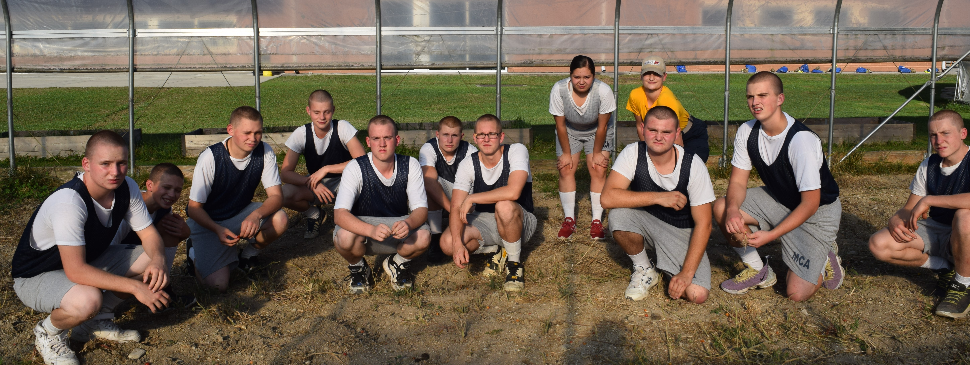

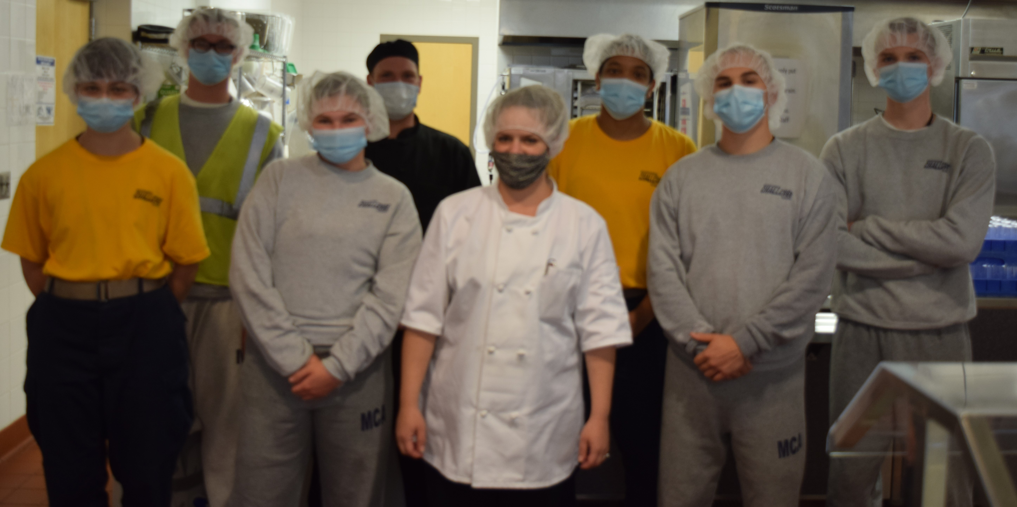

Two additional awards are given during the final Progress Reporting Period only. The Good Conduct Ribbon recognizes those Cadets who remained incident free during the six progress reporting periods. The Health Ribbon recognizes those Cadets who have sustained a clean record from Sick Call.
GOOD CONDUCT AWARD
Hannah Atkins | Angel Hoover | Alexis Robinson | Evan Turley
Blake Bailey | Seth Johnson | Hunter Saunders | Damian Vankirk
Austin Carder | Keyanna Jones | Trevor Shafer | Clayton Vest
Ethan Crawford | John Kessler | Jacey Suarez | Nathan Wheeler
Kainon Doyle | Jenaya McNeil | Braxton Taylor
Jacob Dye | Amy Moersen | Jackie Tolbert

HEALTH AWARD
Ethan Crawford
Matthew Rouse
Hanna Starcher
Christian Sturgill
Clayton Vest

CITIZENSHIP RIBBON
All Cadets who completed the Sixth Progress Report received the Citizenship Ribbon. The white ribbon represents the need to do your share to make the Academy and your community better. Get involved, stay informed on the issues of the day and vote. Give back to your community and continue to perform community service. A good citizen gives more than they take.

REMINDER . . . . .
First
Post Residential
Monthly Report
due December 22nd
and the
22nd of every month for one year.

IMPORTANT INFORMATION
We will accept check or money order payment made to MCA to cover all outstanding bills.
All valuable documents including Graduation Certificates, TASC documents, resumes, training certifications and final progress reports will be in a large envelope the Cadets receive after the ceremony.

Do not lose this graduation packet!

CITIZENSHIP RIBBON
All Cadets who completed the Sixth Progress Report received the Citizenship Ribbon. The white ribbon represents the need to do your share to make the Academy and your community better. Get involved, stay informed on the issues of the day and vote. Give back to your community and continue to perform community service. A good citizen gives more than they take.

Congratulations Class 2-20 NORTH

Greet the future with
anticipation.
Dream big & work hard!
Remember your roots,
manners & the way home.

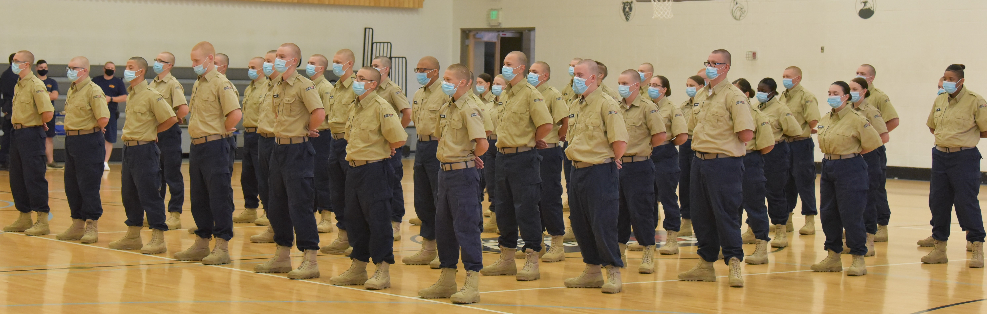

GRADUATION . . . . .
Thank you families! You have helped your child reach this milestone. MCA could not do it alone. Enjoy a safe and happy holiday season as the graduates enter the Post Residential Phase.
Dianna Trickett
Director

