The ChalleNGer

Class 2-20, Issue 4 09/04/2020 – 09/24/2020
4th PROGRESS REPORT AWARD WINNERS
www.wvchallenge.org
HONOR PLATOON
4th Platoon

DIRECTOR’S AWARD |  | Alexis Robinson of Kanawha County
LEADERSHIP AWARD |  | Hannah Atkins of Kanawha County
PHYSICAL TRAINING AWARD |  | Alexis Robinson of Kanawha County
HIGHEST ACADEMIC POINTS
Hannah Atkins

CADET OF THE DAY
09/04 | Alexis Robinson
09/08 | Blake Bailey
09/09 | Jacey Suarez
09/10 | Hunter Saunders
09/11 | Blake Bailey
09/14 | Alexander Miller
09/15 | Trevor Shafer
09/16 | Austin Carder
09/17 | Matthew Fernandes
09/18 | Colton Shahan
09/21 | Blake Bailey
09/22 | Kainon Doyle
09/23 | Keyanna Jones
09/24 | Hanna Starcher

OVERALL | ACADEMIC | PT | CADRE
MOST IMPROVED | MOST IMPROVED | MOST IMPROVED | DISTINCTION AWARD
Hanna Starcher | Ethan Crawford | Jayden Churchill | Jackie Tolbert

HONOR’S LIST

Kainon Doyle Keyanna Jones
Noah Hannas Hunter Saunders
Angel Hoover Braxton Taylor

LEVEL ONE PT

Alexis Robinson
Evan Turley
LEADERSHIP APPOINTMENTS
Corps Commander:
Alexis Robinson
Assistant Corps Commander:
Hannah Atkins
Platoon Leaders:
Blake Bailey
Seth Johnson
Hunter Saunders
Evan Turley
Miah Jordan
Hanna Starcher
Assistant Platoon Leaders:
Austin Carder
Noah Hannas
Christian Sturgill
Jackie Tolbert
Angel Hoover
Amy Moersen

INSTRUCTORS LIST
Hannah Atkins |  | Kainon Doyle | Miah Jordan | Alexis Robinson | Christian Sturgill
Blake Bailey |  | Caroline Fazzolari | John Kessler | Hunter Saunders | Jacey Suarez
Austin Carder |  | Noah Hannas | Jenaya McNeil | Alex Shumaker | Evan Turley
Jayden Churchill |  | Angel Hoover | Alexander Miller | Hanna Starcher | Clayton Vest
Samarra Croston |  | Seth Johnson | Amy Moersen | Brialyn Strahin | Nathan Wheeler

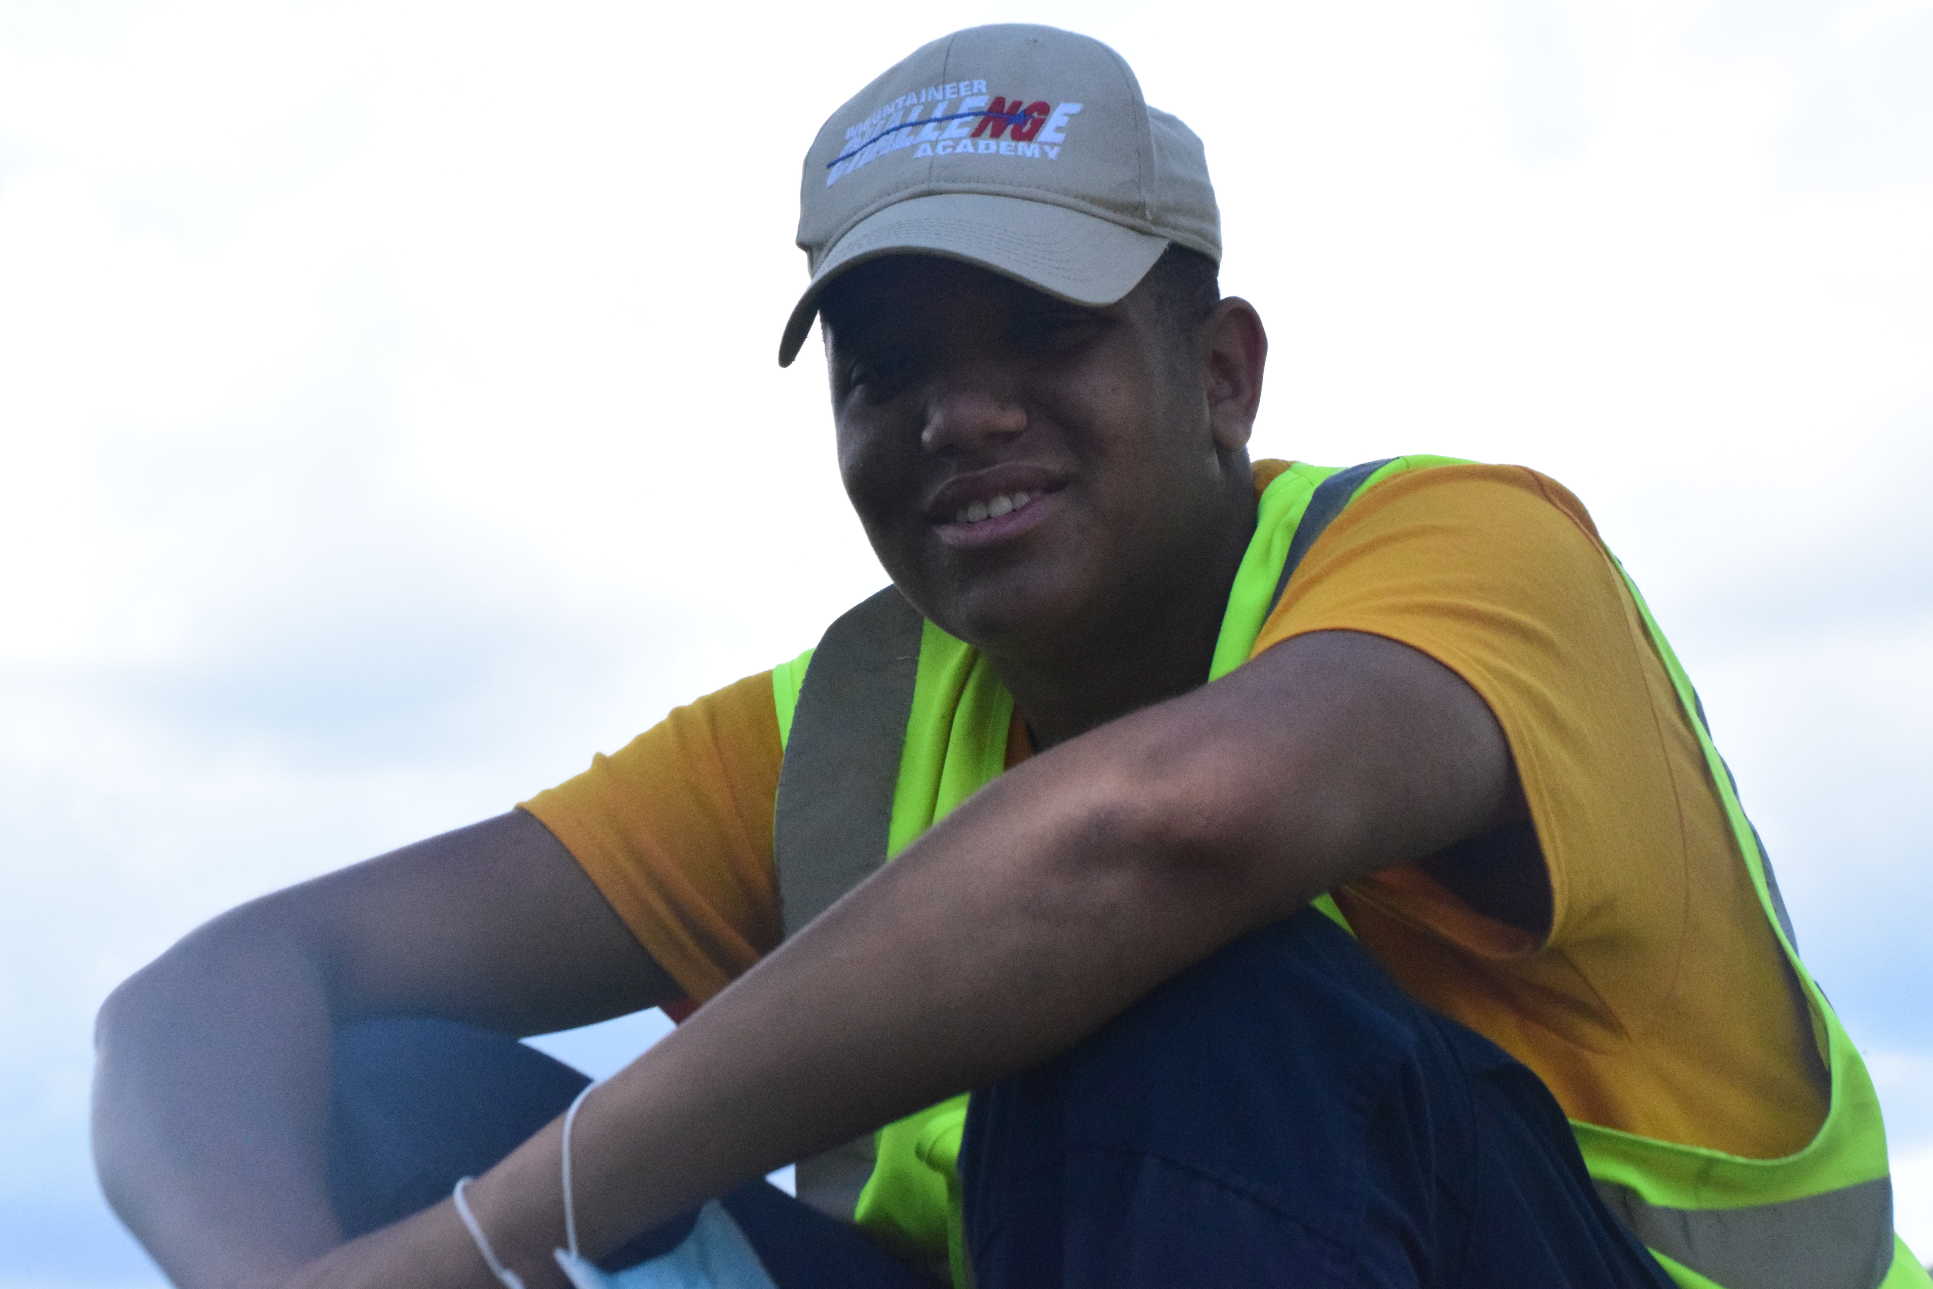

SERVICE TO COMMUNITY
During weeks 3-19 of the Residential Phase, the Cadets receive instruction centered around the 8 Core Components. One of these Core Components is Service to Community. Cadets develop an understanding of the benefits to be gained through volunteerism in community service projects and agencies. Cadets volunteer many hours during the program performing services for oganizations such as the American Red Cross Blood Drive, Brown Bag for Vets, Burlington Apple Butter Festival, Kingwood and Reedsville VFD, Rowlesburg Park, and Shafer Heritage Farms to name a few. 100% of the Cadets participate in work and service projects, which will develop and improve work habits, work skills, and sense of community involvement. Each Cadet is required to perform 40 hours of Service To Community. Certificates of Appreciation and Letters of Recommendation are presented to Cadets from the recipients at final graduation as part of the Cadet’s portfolio.

COVID-19 did not deter Cadets from participating in Service To Community events. In true Military form, Cadets adapted to the situation and came up with alternative projects to meet the Core Component requirement. Cadets regularly performed area beautification of the Camp Dawson grounds and assisted on a variety of maintence projects such as painting. Several Cadets learned the skill of crochet to which they made various items for local nursing homes and care facilities.

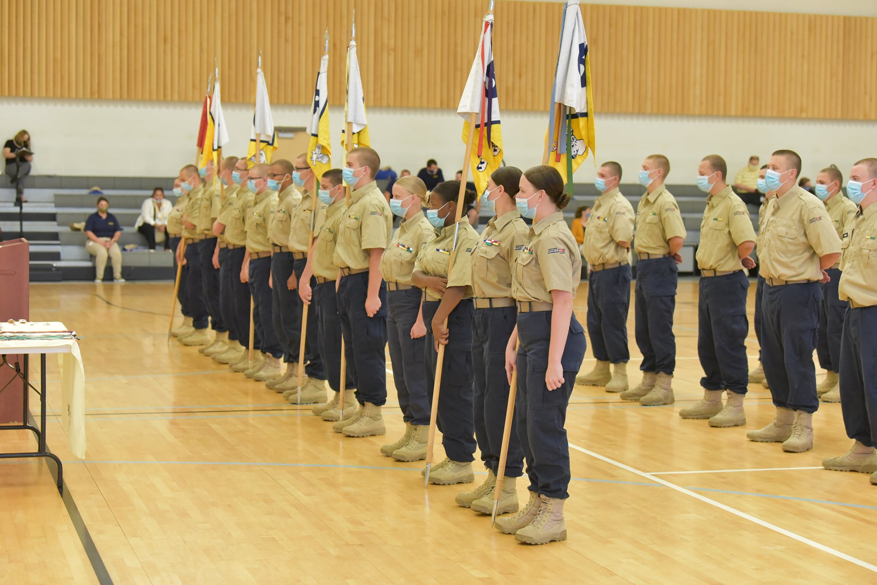
Important Information
Optional Purchases Available
- Pictures – Various Packages and Items Available.
- Class Ring – Total Cost $156.88

If you have not received an order
form or have questions, please call
1-800-529-7700
Graduation
Due to COVID issues and limited access to Camp Dawson, Graduation will be held in a virtual, on-line environment. No family, friends or mentors will be allowed to attend the in-person ceremony.

Mountaineer Challenge Academy will stream the Graduation event live on Facebook via the Academy Facebook page.

Date: Friday, November 20, 2020
Time: 1:00 pm

Cadet Pick-up after Graduation
Cadet Pick-up will be on Saturday, November 21, 2020. Pickup will be held at the AFRC Facility where Cadets were processed on Opening Day in July. A time schedule will be forthcoming for pickup based off driving times to the Camp Dawson area. Stay tuned for further direction.

What does an MCA Class Ring look like?

This design was selected by the first graduating class.

SCHEDULE OF EVENTS
10/15 | 5th Grading Period Ends
10/19-10/21 | TASC Re-Test
10/23 | PR 5 Awards Ceremony
10/26-10/28 | TASC Re-Test
11/03 | Election Day

TRUSTWORTHINESS RIBBON
All Cadets who completed the Fourth Progress Report received the Trustworthiness Ribbon. The blue ribbon represents the need to be honest, be reliable and do what you say you will do. Have the courage to do the right thing and always live by your “Honor Code.” Be someone who others can trust.

