The ChalleNGer

CADET OF THE DAY
Individuals chosen as Cadet of the Day are selected from the Platoon of which they are a member. The Squad Leaders will inspect the Platoon. Platoon winners compete for the title of “Cadet of the Day” by answering questions related to MCA, State of WV, or TASC topics.

07/27 | Jacob Dye
07/28 | Kainon Doyle
07/29 | Jenaya McNeil
07/30 | Danielle Brown
07/31 | Hunter Saunders
08/03 | Miah Jordan
08/04 | Trevor Shafer
08/05 | Colton Shahan
08/06 | Hanna Starcher
Class 2-20, Issue 1 07/25/2020 – 08/06/2020
1st PROGRESS REPORT AWARD WINNERS
Being Unique Is What This Class Is All About
As the COVID-19 pandemic continues throughout the United States, the Mountaineer ChalleNGe Academy continues to move forward with the start of Class 2-20 on July 12, 2020. With this being said, things looked a little different for the staff and candidates on Opening Day.

- Opening Day itself was conducted at the Armed Forces Reserve Center on River Rd in Kingwood as an outside processing center with mobile COVID testing conducted on each candidate instead of on the MCA Campus at Camp Dawson.
- The number of Candidates invited were limited to 50, which is a number that the Program has never seen from its inception. The very first class, class 1-94, registered 64 candidates on its Opening Day.
- The faces of the Candidates all looked familiar. You know, those faces that you’ve seen before because they look like another Cadet who graduated in an earlier class. These Candidates looked familiar because they were actually Cadets from Class 1-20. On March 21, 2020, Maj. Gen. James Hoyer, the adjutant general of the WVNG, made a difficult decision to send all the Cadets home until it was safe to bring the students back. Following their departure, the Cadets were given 3 options: 1. Continue their online education and return in June to complete TASC Testing for the completion of the MCA. 2. Discontinue their online education and return to Class 55 and restart the program from day 1. 3. Terminate from the program. These 45 Cadets all chose to return and complete the challenge in the traditional manner and started over.
- MCA is running as a closed campus, they will forego their 2 mandatory leaves home, and will graduate on Saturday, November 21, 2020, which is 3 weeks earlier than the traditional graduation time frame.

Thank you, Class 55, for stepping up and committing to completing the ChalleNGe not only once but twice and preparing yourself for a brighter future!
www.wvchallenge.org
LEADERSHIP APPOINTMENTS
Corps Commander
Hannah Atkins
Assistant Corps Commander
Jackie Tolbert
Platoon Leaders:
Blake Bailey
Seth Johnson
Hunter Saunders
Evan Turley
Miah Jordan
Alexis Robinson
Assistant Platoon Leaders:
Austin Carder
Alexander Miller
Trevor Shafer
Clayton Vest
Samarra Croston
Amy Moersen

HONOR PLATOON
2nd Platoon

LEVEL ONE PT
Alexis Robinson

CADRE DISTINCTION AWARD
Braxton Taylor

HIGHEST ACADEMIC POINTS
Hannah Atkins
Amy Moersen

DIRECTOR’S AWARD |  | Hannah Atkins of Kanawha County
LEADERSHIP AWARD |  | Jackie Tolbert of Jackson County
PHYSICAL TRAINING AWARD |  | Alexis Robinson of Kanawha County

S2C AWARD
Trevor Shafer
Evan Turley

Guidon Presentation
The Company Colors were presented to Class 2-20 who earned the privilege of carrying the MCA colors by successfully completing the Acclimation Phase. The Company Guidon is the cornerstone on which to build team performances and individual achievements. The Company Guidon is designated by the Class Streamer with the class number and the phase streamers that signify class progress during the program. All Platoons received their individual Guidons, which identify the Platoon number and mascot. Award Streamers are presented every three weeks to recognize their accomplishments in education, PT, Service to Community and conduct.
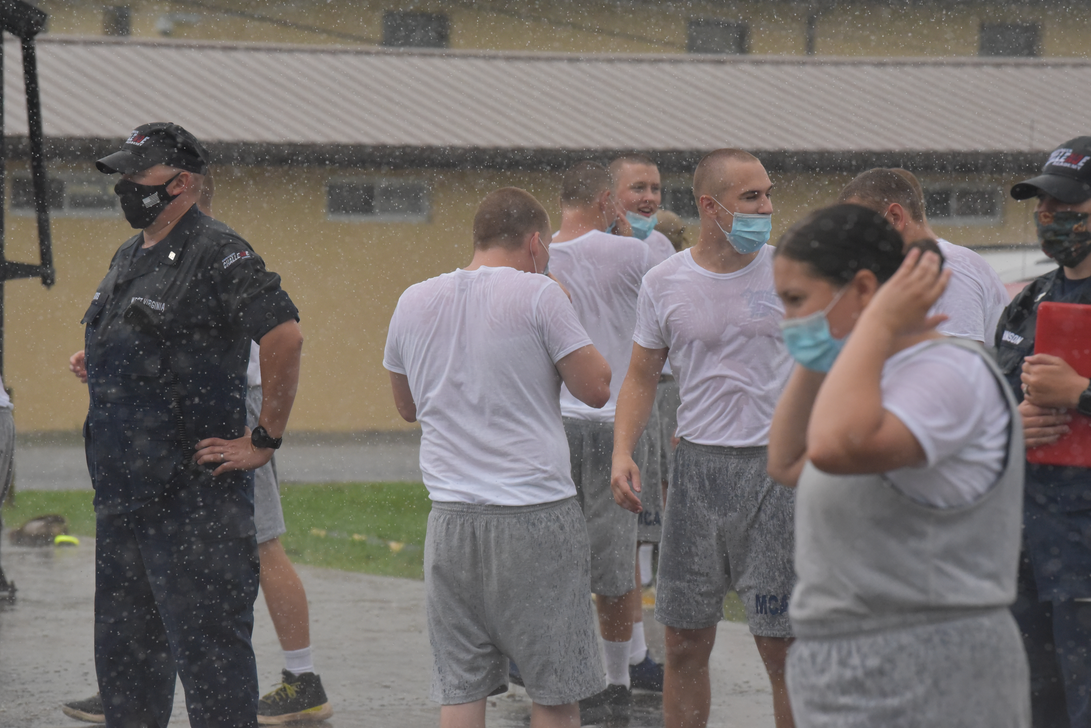
Cadets Enjoy Platoon Olympics
On Friday, July 24th, the Cadets participated in MCA Platoon Olympics. In order to maintain social distancing, Platoon Olympics took place outdoors and ended abruptly with a down pour and lots of wet Cadets and Staff. The Cadets loved it; the Staff, well, maybe not as much. Each of the 6 Platoons competed in the following events: Mystery Competition, Duffle Bag Relay, Football Toss, Lay Up Relay, Free Throw Competition, Trivia Relay, Corn Toss, and Mystery Relay. Platoon 1 was the first-place winner and was honored by getting to be the first in the Chow Line.

RESPECT RIBBON
All Cadets who completed the First Progress Report received the Respect Ribbon. Treat others the way you want to be treated. Respect the dignity, privacy, and freedom of all individuals. Value and honor all people, no matter what they can do for you or to you. Respect others, the Academy, yourself and follow the ‘Golden Rule.’ Self-respect leads to self-discipline. Self-Discipline is the art of resisting the temptations of life.

Did You Know?
- Mountaineer ChalleNGe Academy offers a salad with every lunch and dinner. Vegetables are an important source of fiber. Fiber helps keep blood sugar stable throughout the day, preventing the peaks and crashes that have us craving sweets.
- Cadets carry canteens and are encouraged to drink eight 8 ounce glasses of water a day. Staying hydrated improves all bodily functions at the cellular level and helps your heart and kidneys work more efficiently. Water carries nutrients and antioxidants to our tissue, resulting in an energy boost.
- Cadets are offered unsweetened ice tea with meals. Unsweetened tea is a zero calorie beverage that may promote heart health by improving blood vessel function.
- Daily physical training helps Cadets stay fit and happy. Because of the calming effect of exercise, active people are less depressed and depressed people often feel better after they start exercising.
- Cadets eat more whole grain products than white, like brown rice and wheat bread. Higher in protein and fiber, whole grain foods keep your blood sugar in check and keep you feeling full longer. Whole grains are versatile, inexpensive and surprisingly easy to prepare.
Source: The Biggest Loser Simple Swaps 100 Easy Changes to Start Living a Healthier Lifestyle

IMPORTANT INFORMATION
If you have questions or concerns regarding your child’s medical care or medications – please call the MCA Medical Office at 304-791-7934. You may leave a message at any time. The office is staffed between 7 am – 12 pm Monday – Friday.

Cadets may NOT receive packages in the mail. Nothing bigger than a greeting card sized envelope or a #10 business envelope is allowed. Stamps are allowed to be included in these mailings.

When writing to Cadets, please make sure your complete name and return address is included on the front of the envelope. Please pass this on to all family and friends!

SCHEDULE OF EVENTS
08/20 | 2nd Grading Period Ends
08/28 | PR 2 Awards Ceremony
09/03 | 3rd Grading Period Ends
09/11 | PR 3 Awards Ceremony

Do you know a teen who could benefit from the mca?

Class 1-21 is now forming!

Tell them or their family member to call
1-800-529-7700

